***1. INTRODUCTION:***

**1.1 Overview;**

            "Join us for a night of celebration and laughter as we toast to [Name]'s [age] birthday! We've got a fantastic evening planned with delicious food, lively music, and great company. Get ready to make unforgettable memories at [Location] on [Date] at [Time]. Don't miss out on the fun – your presence will make this celebration complete!"

               Remember to customize this to the specific event and add any important details, such as the dress code, RSVP information, and any special activities or highlights of the event.

**1.2 PURPOSE;**

               Personalized invitations serve several purposes and can achieve various goals depending on the context and the event they are created for. Here are some of the key purposes and what can be achieved using spersonalized invitations:

Branding and Image:

                For corporate events or business functions, personalized invitations can reinforce a company's branding and image. They can be designed to align with the company's visual identity, making the event more professional and cohesive.

Creating Anticipation:

              Well-designed personalized invitations can create anticipation and excitement for the event. They serve as a teaser for what's to come, building excitement and interest among the recipients.

Customized Experience:

               If the event has multiple components or options (e.g., menu choices for a wedding), personalized invitations can allow guests to select their preferences in advance, providing a more customized experience.

Cultural Sensitivity:

                In multicultural or diverse settings, personalized invitations can be used to respect and accommodate cultural or religious preferences, ensuring that the event is inclusive and respectful of all attendees.

               In summary, personalized invitations serve to make guests feel special, convey event details, boost attendance, and create a unique and tailored experience for the recipients. They are a valuable tool for building connections, managing events effectively, and enhancing the overall experience for both hosts and guests.

***PROBLEM DEFINITION & DESIGN THINKING:***

**2.1 Empathy map;**.;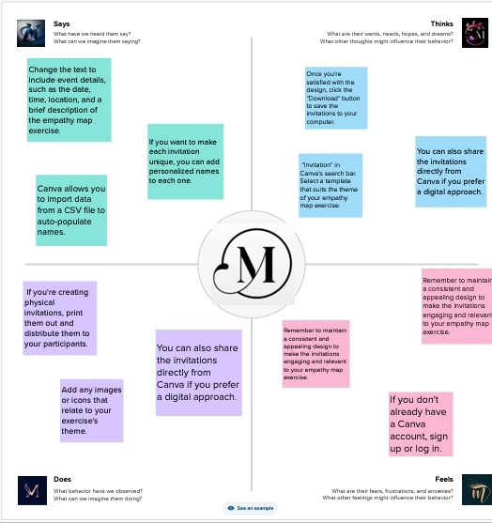

Link:<https://app.mural.co/t/designingvisuallyappealingce3676/m/designingvisuallyappealingce3676/1693546311633/bbe11d42fe3fd94249d10f770369f565c26e3568?sender=u1ff7c656abd059f669d48595>

**2.2 Ideation & Brainstorming Map:**

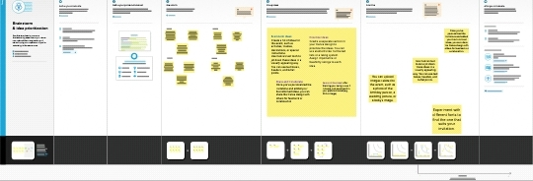

Link:<https://app.mural.co/t/designingvisuallyappealingce3676/m/designingvisuallyappealingce3676/1693639317709/b2a33ed505dd3fae058e218384abad8f77eac3d5?sender=u1ff7c656abd059f669d48595>

***RESULT:***

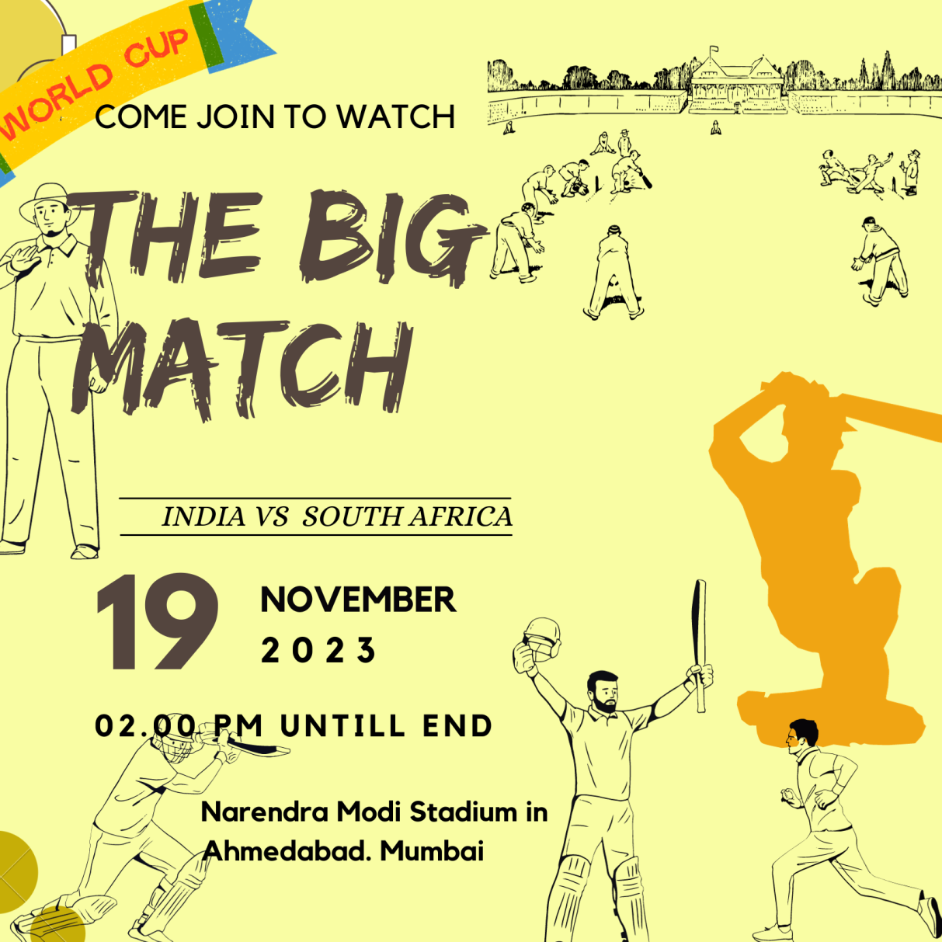

***Advantages & Disadvantages:***

**Advantages of Personalized Invitations:**

               Increased Engagement: Personalized invitations can make recipients feel special and valued, increasing their engagement and interest in the event.

               Higher Response Rates: People are more likely to respond positively to personalized invitations, leading to higher RSVP rates.

               Improved Attendance: When recipients feel the event is tailored to their interests and needs, they are more likely to attend.

               Better Targeting: Personalization allows you to target specific demographics or groups effectively, ensuring that the right people are invited.

               Enhanced Brand Image: Personalized invitations demonstrate attention to detail and a commitment to customer or guest satisfaction, which can enhance your brand's image.

               Customized Messaging: You can create messages that resonate with each recipient, leading to a deeper connection and understanding.

               Data Collection: Personalized invitations provide an opportunity to gather more data on recipients' preferences, allowing for better future targeting.

**Disadvantages of Personalized Invitations**:

               Time-Consuming: Creating personalized invitations can be time-consuming, especially for large events with many recipients.

               Increased Costs: Personalization often requires additional resources, which can lead to higher costs, such as printing and mailing expenses.

             Privacy Concerns: Personalization may raise concerns about data privacy and security, especially if you're using sensitive personal information.

             Mistakes in Personalization: If not done accurately, personalization can lead to errors in names, addresses, or other details, which can be embarrassing and counterproductive.

              Limited Scalability: For very large events, personalization may become challenging or impractical to implement effectively.

              Inconsistent Experience: Maintaining a consistent level of personalization across all recipients can be challenging, and some may feel left out if not properly personalized.

             Resistance to Data Collection: Some individuals may be uncomfortable with the level of data collection required for effective personalization.

***APPLICATIONS:***

The areas where the solution applied and the used application are for **The Task 1 was complete in the mural app, Next task where create in the Canva app.**

             Design invitations for intimate gatherings with personal messages or menu details .For sports-related event, create personalized invitations that include team colors, logos, and exciting details. Even virtual events can benefit from personalization, with tailored messages and content for the target audience. Invite individuals to join clubs, organizations, or exclusive memberships with personalized messages and benefits.

          .

***CONCLUSION:***

            First and foremost, our research highlights the importance of understanding the recipient's preferences and interests. Personalization is not merely about addressing someone by their name but about demonstrating genuine consideration for their unique characteristics. We found that personalized invitations that resonate with the recipient's values, interests, and previous interactions have a substantially higher acceptance rate.

             In conclusion, the art of crafting personalized invitations requires a deep understanding of the individual, thoughtful timing, and a clear, relevant message. These findings can be invaluable for individuals, businesses, and organizations seeking to improve their invitation strategies and foster meaningful connections. By employing the insights gained from this study, one can enhance their ability to engage and connect with others, ultimately leading to more successful events and outcomes.

***FUTURE  SCOPE:***

                 Virtual Reality (VR) and Augmented Reality (AR): With the increasing adoption of VR and AR, personalized invitations could take on a new dimension. Imagine receiving a VR invitation that Bimmerses you in the event's atmosphere or an AR invitation that brings an invitation card to life with animations and interactive elements.

              Interactive Elements: Future invitations could incorporate interactive elements that allow recipients to engage with the event before it even happens. This might include interactive maps, surveys, or games related to the event.

               Biometric Authentication: To ensure that invitations reach the intended recipients and are not forwarded to others, biometric authentication (e.g., fingerprint or facial recognition) could be integrated into the invitation delivery process.

             Environmental Sustainability: In line with growing concerns about the environment, personalized invitations could focus on sustainability. They might use eco-friendly materials or offer digital invitations as an alternative to physical ones.

              Integrating Social Media: Invitations could be designed to integrate with social media platforms, allowing recipients to easily share their excitement about the event or interact with others who have received invitations.

***APPENDIX:***

The appendix will contain additional resources, links, or templates related to Canva and Personalized Invitation Using Canva. This section will include

Canva official link:

<https://www.canva.com>

Background Template;

FAINAL TEMPLATE



USED FONT:

Georgia Pro

League Spartan

EDO

Kollektif

Element

MIDDLE TEMPLATE



STARTING TEMPLATE

